### NEW A127. Dis-Eur-Czech Republic-Moravia-Střelice-Figurine-Female- Ceramic

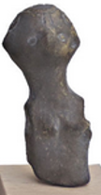

Fig. 1. Czech Republic-Moravia-Střelice-Figurine-Female-Venus-Ceramic

### **Formal Label:** Czech Republic-Moravia-Střelice- Figurine-Female-Venus-Ceramic

**Display Description:** Střelice Moravian ceramic figurines, such as this one, were located in the context of habitations (notably near hearths, see Sázelová 2008) in settled areas in large reoccupied sites near agricultural resources (Čižmář et alii 2008), which near this site is still being farmed today. A very conservative figural grammar (Humpolová and Podborský 2013) was evidently sustained for many generations based on C14 data (Kuča 2012, 2011). This particular figurine was fractured in antiquity: It has lost both arms and legs. Fracturing ritual figurines inside a habitation was common when the houses were ritually burned and the household was moved and figurines inside were ritually broken. This figurine is also unusual in that its facial features and its hairdo are carefully modeled.

### ****Accession Number:**** A127

### LC Classification: GN772

**Date or Time Horizon:** 4,850 BCE-4,450 BCE

**Geographical Area:** Czech Republic, Moravia,Střelice

**Maps** from http://latitude.to/img/latitude-logo.svg; **GPS Coordinates:** 49.15694 16.50889;40° 26' 46" N 79° 58' 56" W

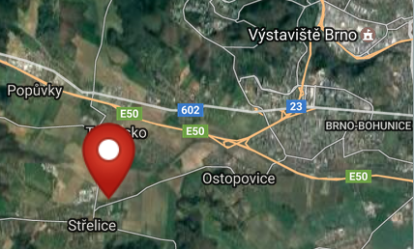 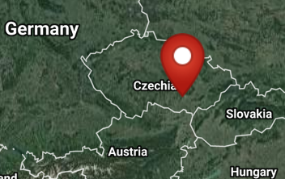

**Cultural Affiliation:** Neolithic

**Medium:** Fired clay.

**Dimensions:**

**Weight:**

**Condition: Resin replica of original.**

**Provenance:** Czech Republic, Moravia,Střelice Museum.

**Discussion:**

The small breasts and the long hair of this figurine are the two traits of this figurine being female. Since the portion of the figurine is missing below the abdomen we have no way of knowing what was the configuration of the rest of the body. Traditionally this would have been more corpulent and was a sign associated with a general social and medical anxiety for safe childbirth. Figurines incorporating indications of these anxieties may have accompanied the instructions (perhaps incorporated in rituals) by women midwives who had expertise in the care of pregnant mothers and the practice and art of delivering babies safely.In Neolithic communities it is important to have many children as the farm-work required many hands. Midwives still perform the same tasks to assist their communal sisters in pregnancy and childbirth. Indeed, a similar anxiety to have many children is noticeable today among traditional farming families in many parts of the world, especially in Africa, India, and South America.

**References:**

Čižmář, Zdeněk, ed*.* 2008. *Život a smrt v mladší době kamenné. Katalog výstavy. Leben und Tod in der Jungsteinzeit.* [Life and Death in the New Stone Age.] Brno:Ústav archeologické památkové péče ve spolupráci s Jihomoravskzm muzeem ve Znojmě a Moravským zemským muzeem v Brně.

Humpolová, Alena and Vladimír Podborský. 2013. *To nejlepší z archeologické sbírky Františka Vildomce.* [The Best of the Archaeological Collection of František Vildomec]. Brno: Moravské zemské muzeum.

Králík, Miroslav and Novotný, Vladimír. 2005. Dermatoglyphics of Ancient Ceramics. In: Svoboda Jiří, ed. *Pavlov I Southeast. A Window into the Gravettian Lifestyles*. Brno: Academy of Sciences of the Czech Republic, Institute of Archaeology, and Kraków: Polish Academy of Sciences, Institute of Systematics and Evolution of Animals, Chapter IV.5, pp. 449-430.

Kuča, Martin, Jan Josef Kovář, Miriam Nývltová Fišáková, Petr Škrdla, Lubomír Prokeš, Miroslav Vaškových, and Zdeněk Schenk. Chronologie neolitu na Moravě. Předběžné výsledky. 2012. [Chronology of the Moravian Neolithic. Preliminary results.] Přehled výzkumů, 53(1).

Kuča, Martin, Jan Josef Kovář, Miriam Nývltová Fišáková, Petr Škrdla, Lubomír Prokeš, Miroslav Vaškových, and Zdeněk Schenk. 2011. Chronologie neolitu na Moravě: Předběžné výsledky,” *Přehled výzkumů*, 53(1).

Sázelová, Sandra. 2008. “Female Figurines of Northern Eurasia: An Ethnological Approach.” In Svoboda, Jiří A., *Petřkovice. On Shouldered Points and Female Figurines.* The Dolní Věstonice Studies, Vol. 15, Brno: Academy of Sciences of the Czech Republic, Institute of Archaeology, pp. 224-232.

Svoboda, Jiri, Vojen Lozek, and Emanuel Vlcek. 1996. *Hunters between East and West, the Paleolithic of Moravia*. New York: Plenum Press; New York: Springer.